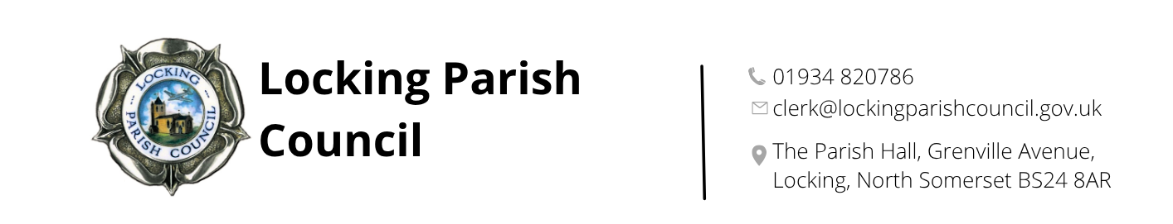

Hire Charges

Main Hall

Parties/Dances/Meetings | Parish | Non-Parish
Adult Rate (per hour) | £13.05 | £23.00
Youth U14 Rate (per hour) | £10.63 | £15.48

Charitable Organisations/Community Groups | Parish | Non-Parish
Adult Rate (per hour) | £10.63 | £19.29
Youth U14 Rate (per hour) | £4.97 | £7.16

Nurse Thomas Suite

Meeting Room | £10.00 per hour

All prices quoted are per hour and include use of a kitchen and toilets. Setting up and clearing away MUST be taken into consideration when working out the time you wish to hire the hall from and until.

The parish rate applies to residents of Locking Village, Locking Parklands, Locking Grove, Flowerdown and Oak Tree Park.

Please contact us should you wish to book the main hall and Nurse Thomas Suite together for your event.

Crockery hire: £7.15 per session. Refundable deposit payable in advance £10 (plus any breakages)

